*DSA0203 - COMPUTER VISION WITH OPEN CV FOR IMAGE PROCESSING*

NAME: A KIRUBIA

REGISTER NUMBER: 192124132

1.Perform basic Image Handling and processing operations on the image. • Read an image in python and Convert an Image to Grayscale

AIM:

To Perform Basic Operations to Read Image and Convert to Grayscale using Python

PROGRAM:

import cv2

import numpy as np

kernel=np.ones((5, 5), np.uint8)

print(kernel)

path="D:\py\photo-1597655601841-214a4cfe8b2c.jpeg"

img=cv2.imread(path)

imgGray=cv2.cvtColor(img,cv2.COLOR_BGR2GRAY)

cv2.imshow("GrayScale", imgGray)

cv2.waitKey(0)

INPUT:

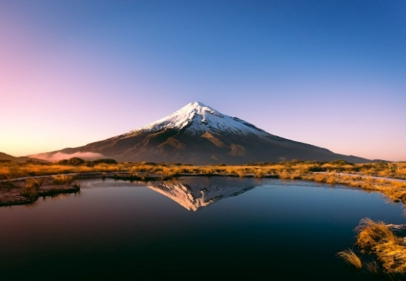

OUTPUT:

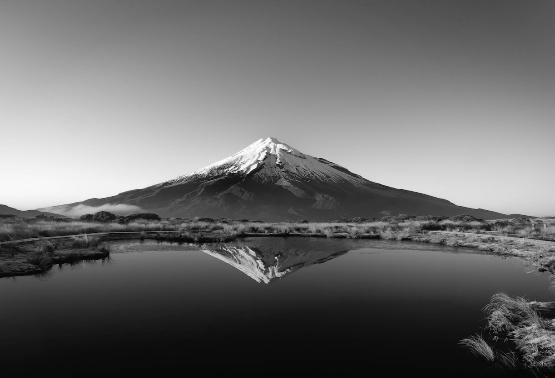

2. Perform basic Image Handling and processing operations on the image.• Read an image in python and Convert an Image to Blur using GaussianBlur.

AIM:

To Perform Basic Operations to Read Image and Convert to Blur using GaussianBlur

PROGRAM:

import cv2

import numpy as np

kernel=np.ones((5,5), np.uint8)

print(kernel)

path="D:\py\photo-1597655601841-214a4cfe8b2c.jpeg"

img=cv2.imread(path)

imggray=cv2.cvtColor(img, cv2.COLOR_BGR2GRAY)

imgblur=cv2.GaussianBlur(imggray, (7,7),0)

cv2.imshow("Img blur", imgblur)

cv2.waitKey(0)

INPUT:

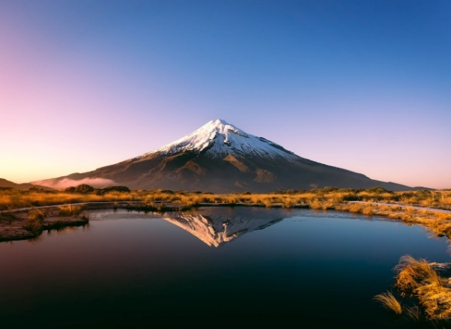

OUTPUT:

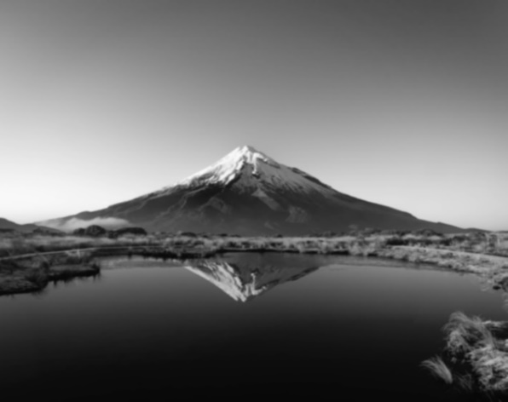

3. Perform basic Image Handling and processing operations on the image• Read an image in python and Convert an Image to show outline using Canny function

AIM:

To Perform Basic Operations to Convert image to show outline Canny function in Python

PROGRAM:

import cv2

import numpy as np

kernel=np.ones((5,5), np.uint8)

print(kernel)

path="D:\py\photo-1597655601841-214a4cfe8b2c.jpeg"

img=cv2.imread(path)

imggray=cv2.cvtColor(img, cv2.COLOR_BGR2GRAY)

imgblur=cv2.GaussianBlur(imggray, (7,7),0)

imgcanny=cv2.Canny(imgblur, 100, 200)

cv2.imshow("Img Canny", imgcanny)

cv2.waitKey(0)

INPUT:

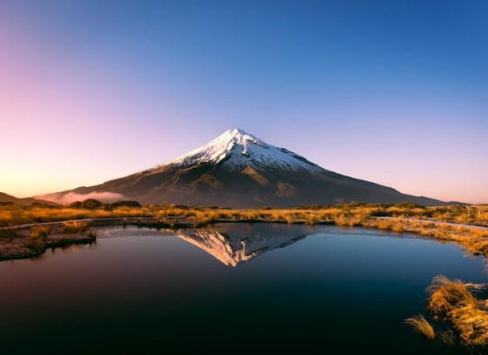

OUTPUT:

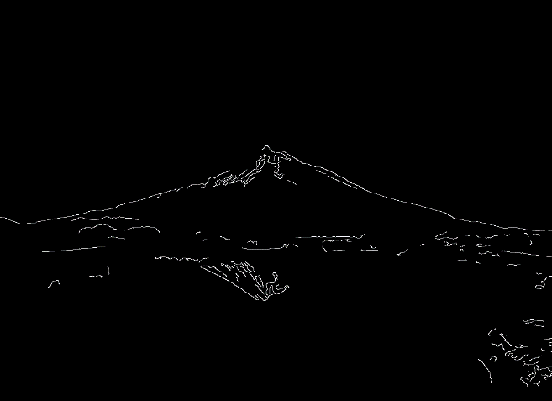

4. Perform basic Image Handling and processing operations on the image• Read an image in python and Dilate an Image using Dilate function

AIM:

To Perform Basic Operations to Read Image and Dilate an Image using Python

PROGRAM:

import cv2

import numpy as np

kernel=np.ones((5,5), np.uint8)

print(kernel)

path="D:\py\photo-1597655601841-214a4cfe8b2c.jpeg"

img=cv2.imread(path)

imggray=cv2.cvtColor(img, cv2.COLOR_BGR2GRAY)

imgblur=cv2.GaussianBlur(imggray, (7,7),0)

imgcanny=cv2.Canny(imgblur, 100, 200)

imgdilation=cv2.dilate(imgcanny, kernel, iterations=10)

cv2.imshow("Img Dilation", imgdilation)

cv2.waitKey(0)

INPUT:

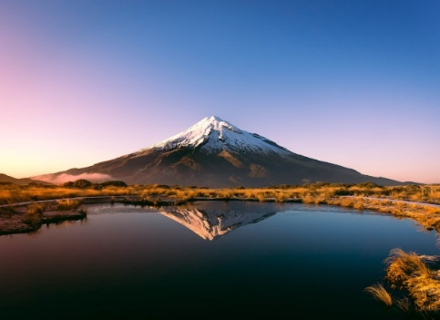

OUTPUT:

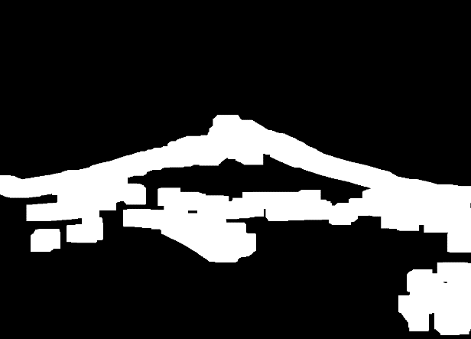

5. Perform basic Image Handling and processing operations on the image• Read an image in python and Erode an Image using erode function

AIM:

The Aim of the experiment is to Read an image in python and Erode an Image using erode function

PROGRAM:

import cv2

import numpy as np

kernel=np.ones((5,5), np.uint8)

print(kernel)

path="D:\py\photo-1597655601841-214a4cfe8b2c.jpeg"

img=cv2.imread(path)

imggray=cv2.cvtColor(img, cv2.COLOR_BGR2GRAY)

imgblur=cv2.GaussianBlur(imggray, (7,7),0)

imgcanny=cv2.Canny(imgblur, 100, 200)

imgdilation=cv2.dilate(imgcanny, kernel, iterations=10)

imgeroded=cv2.erode(imgdilation, kernel, iterations=2)

cv2.imshow("Img erosion", imgeroded)

cv2.waitKey(0)

INPUT:

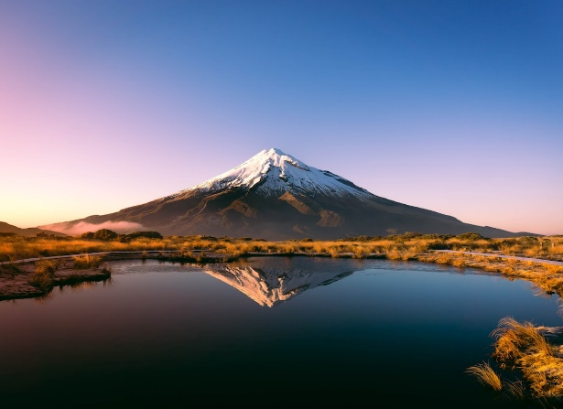

OUTPUT:

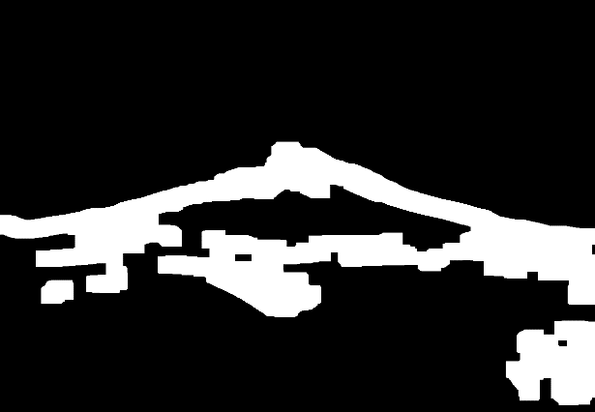

6. Perform basic video processing operations on the captured video• Read captured video in python and display the video, in slow motion and in fast motion.

AIM:

The Aim of the Experiment is to Read captured video in python and display the video, in slow motion and in fast motion

PROGRAM:

import cv2

import numpy as np

cap=cv2.VideoCapture("D:\py\The Summer I Turned Pretty ( S1E1-meeting scene).mp4")

if(cap.isOpened()==False):

print("Error opening video file")

while(cap.isOpened()):

ret,frame=cap.read()

if ret==True:

cv2.imshow('Frame',frame)

if cv2.waitKey(250) & 0xFF==ord('q'):

break

else:

break

cap.release()

cv2.destroyAllWindows()

INPUT:

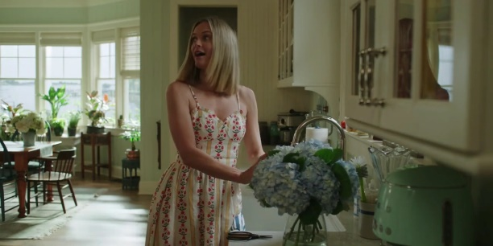

OUTPUT:

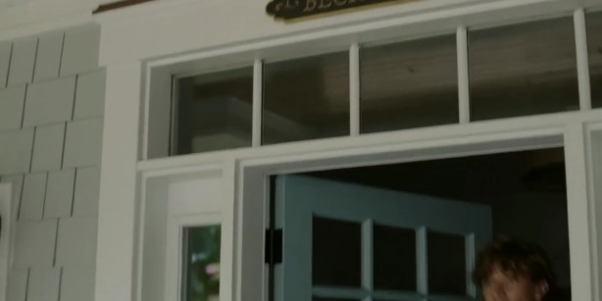

7. Capture video from web Camera and Display the video, in slow motion and in fast motion operations on the captured video

AIM:

The Aim is to Capture video from web Camera and Display the video, in slow motion and in fast motion operations on the captured video

PROGRAM:

import cv2

cap=cv2.VideoCapture(0)

height=int(cap.get(cv2.CAP_PROP_FRAME_HEIGHT))

width=int(cap.get(cv2.CAP_PROP_FRAME_WIDTH))

fps=cap.get(cv2.CAP_PROP_FPS)

path="0"

fourcc=cv2.VideoWriter_fourcc(*'mp4v')

output=cv2.VideoWriter(path,fourcc,2,(width,height))

while True:

ret, frame=cap.read()

cv2.imshow("frame",frame)

output.write(frame)

k=cv2.waitKey(24)

if k==ord("q"):

break

cap.release()

output.release()

cv2.destroyAllWindows()

OUTPUT:

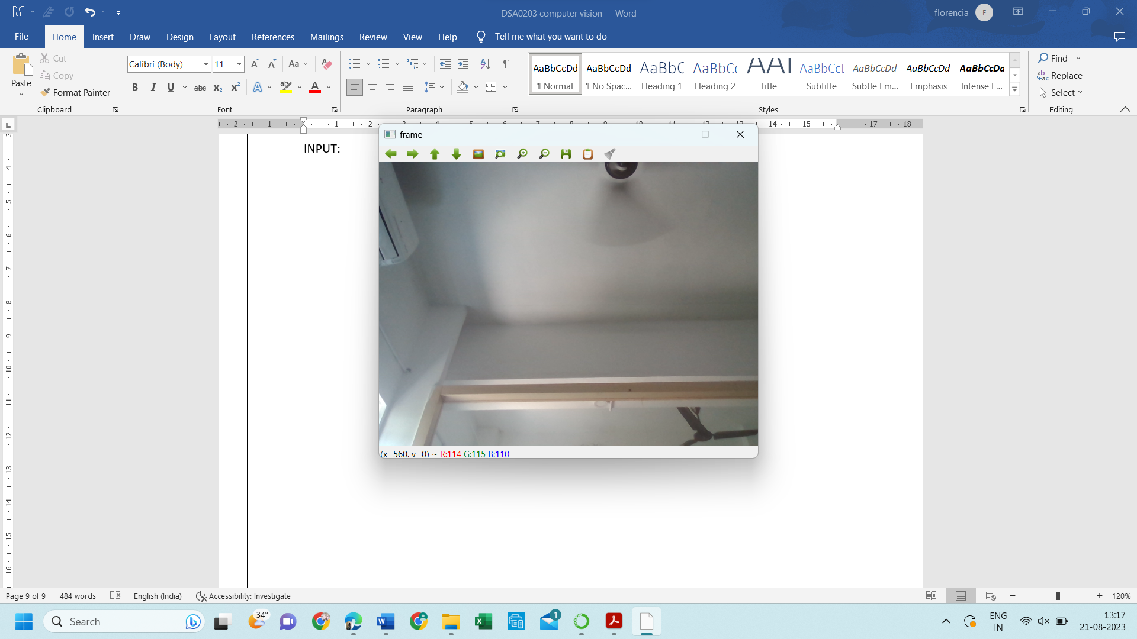

8. Scaling an image to its Bigger and Smaller sizes.

AIM:

The Aim is resize the image from bigger to smaller size

PROGRAM:

import cv2

import numpy as np

kernel=np.ones((5,5),np.uint8)

img=cv2.imread("D:\py\cutest-pet-puppy-dog-image.jpg",cv2.IMREAD_COLOR)

img=cv2.resize(img,(600,600))

cv2.imshow('image',img)

cv2.waitKey(0)

INPUT:

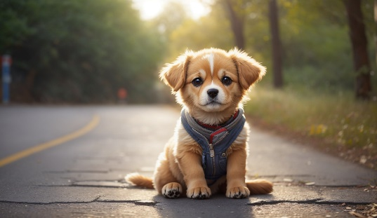

OUTPUT:

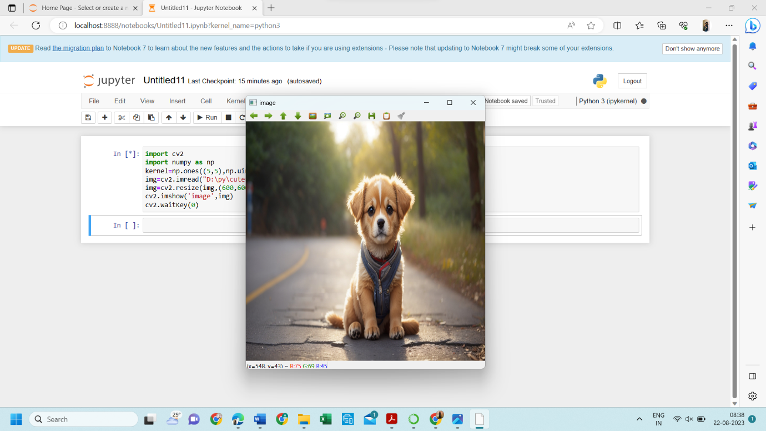

9. Perform Rotation of an image to clockwise and counter clockwise direction.

ROTATION 90 ALONG DEGREE:

AIM :

The Aim of the Experiment is to perform Rotation of an image along 90 degree

PROGRAM:

import cv2

path=r"D:\py\cutest-pet-puppy-dog-image.jpg"

src=cv2.imread(path)

img=cv2.rotate(src,cv2.ROTATE_90_CLOCKWISE)

cv2.imshow("image",img)

cv2.waitKey(0)

INPUT:



OUTPUT:

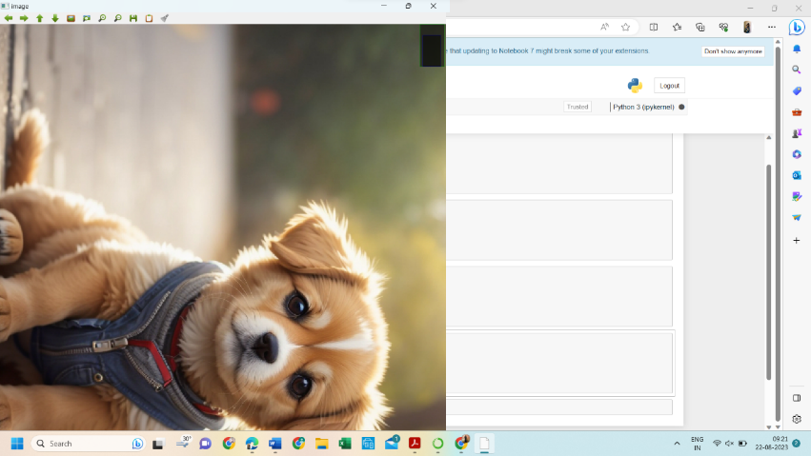

ROTATION ALONG 180 DEGREE

AIM :

The Aim of the Experiment is to perform Rotation of an image along 180 degree

PROGRAM:

import cv2

path=r"D:\py\cutest-pet-puppy-dog-image.jpg"

src=cv2.imread(path)

image=cv2.rotate(src,cv2.ROTATE_180)

cv2.imshow("image",image)

cv2.waitKey(0)

INPUT:



OUTPUT:

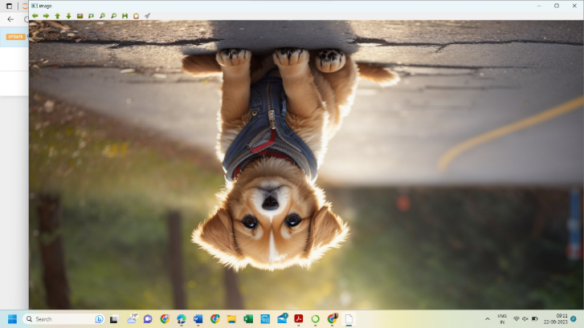

ROTATION ALONG 270 DEGREE

AIM :

The Aim of the Experiment is to perform Rotation of an image along 270 degree

PROGRAM:

import cv2

path=r"D:\py\cutest-pet-puppy-dog-image.jpg"

src=cv2.imread(path)

img=cv2.rotate(src,cv2.ROTATE_90_COUNTERCLOCKWISE)

cv2.imshow("image",img)

cv2.waitKey(0)

INPUT:

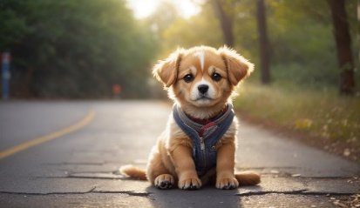

OUTPUT:

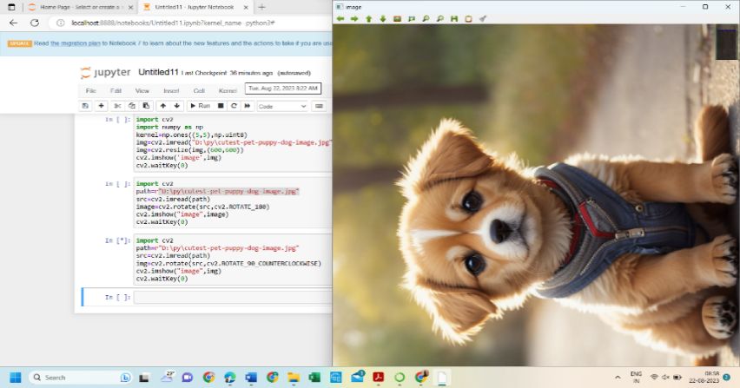

11. Perform Affine Transformation on the image.

PROGRAM:

import cv2

import numpy as np

img=cv2.imread("D:\py\cutest-pet-puppy-dog-image.jpg")

rows,cols,_=img.shape

pts1=np.float32([[50,50],[200,50],[50,200]])

pts2=np.float32([[10,100],[200,50],[100,250]])

M=cv2.getAffineTransform(pts1,pts2)

dst=cv2.warpAffine(img,M,(cols,rows))

cv2.imshow("Affine transform",dst)

cv2.waitKey(0)

cv2.destroyAllWindows()

INPUT:



OUTPUT:

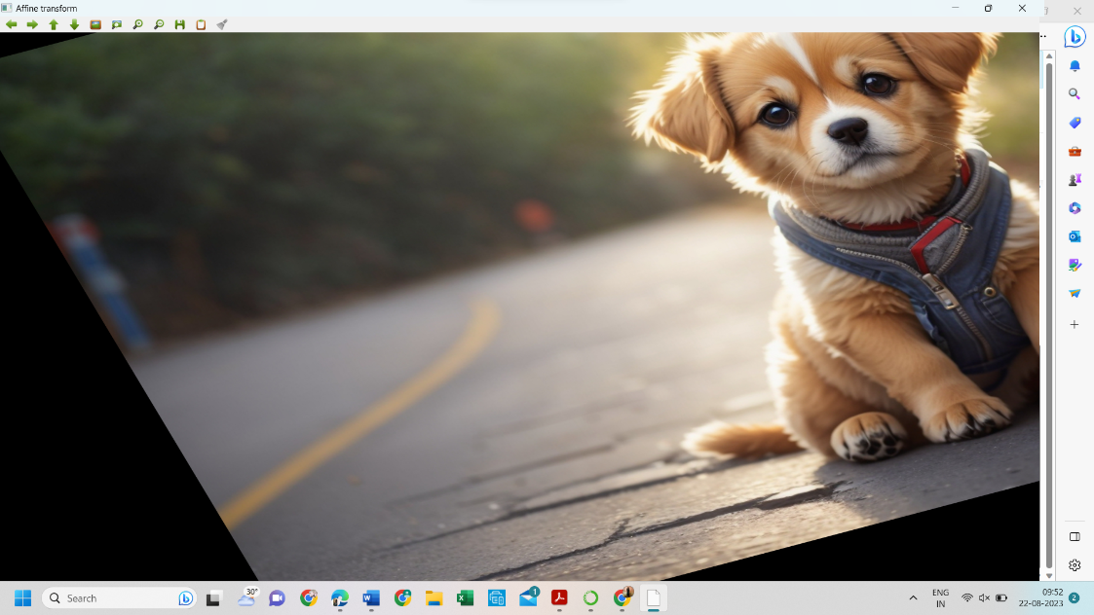

12. Perform Perspective Transformation on the image.

PROGRAM:

import cv2

import numpy as np

img=cv2.imread("D:\py\cutest-pet-puppy-dog-image.jpg")

rows,cols,ch=img.shape

pts1=np.float32([[56,65],[368,52],[28,387],[389,390]])

pts2=np.float32([[100,50],[300,0],[0,300],[300,300]])

m=cv2.getPerspectiveTransform(pts1,pts2)

dst=cv2.warpPerspective(img,m,(cols,rows))

cv2.imshow("perspective transform",dst)

cv2.waitKey(0)

cv2.destroyAllWindows()

INPUT:



OUTPUT:

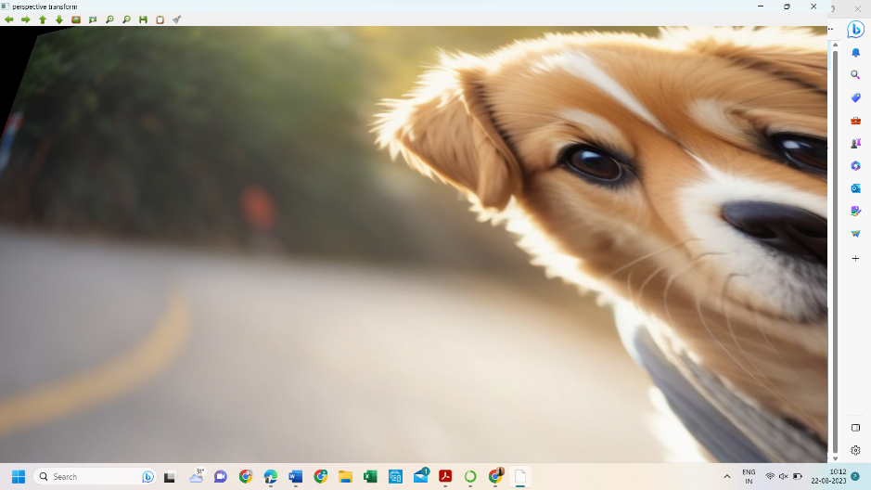

13. Perform Perspective Transformation on the Video.

PROGRAM:

import cv2

import numpy as np

cap = cv2.VideoCapture(r"D:\py\The Summer I Turned Pretty ( S1E1-meeting scene).mp4")

while True:

ret, frame = cap.read()

if not ret:

break

pts1 = np.float32([[200, 300], [5, 2], [0, 4], [6, 0]])

pts2 = np.float32([[0, 0], [4, 0], [0, 1], [4, 6]])

matrix = cv2.getPerspectiveTransform(pts1, pts2)

result = cv2.warpPerspective(frame, matrix, (frame.shape[1], frame.shape[0]))

cv2.imshow('frame', frame)

cv2.imshow('frame1', result)

if cv2.waitKey(24) == 27:

break

cap.release()

cv2.destroyAllWindows()

INPUT:

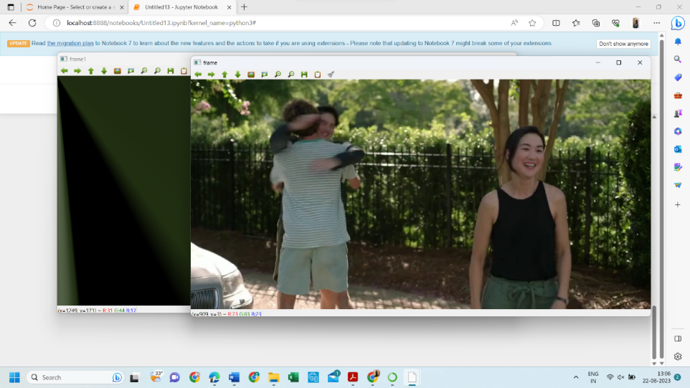

OUTPUT:

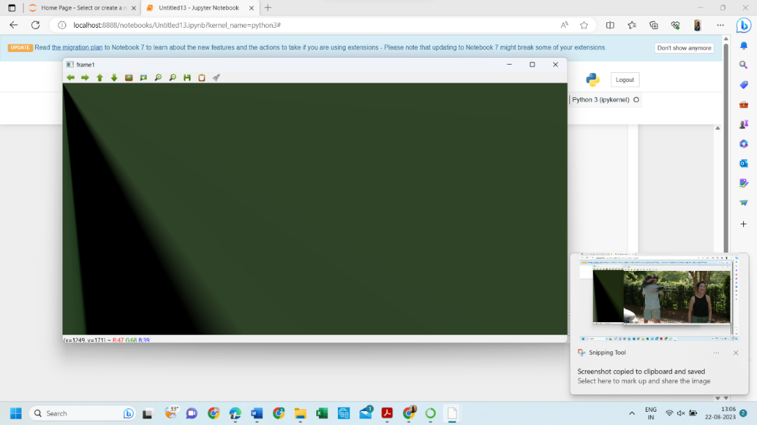

14. Perform transformation using Homography matrix

PROGRAM:

import cv2

import numpy as np

im_src = cv2.imread("D:\py\cutest-pet-puppy-dog-image.jpg")

pts_src = np.array([[141, 131], [480, 159], [493, 630],[64, 601]])

im_dst = cv2.imread("D:\py\cutest-pet-puppy-dog-image.jpg")

pts_dst = np.array([[318, 256],[534, 372],[316, 670],[73, 473]])

h, status = cv2.findHomography(pts_src, pts_dst)

im_out = cv2.warpPerspective(im_src, h, (im_dst.shape[1],im_dst.shape[0]))

cv2.imshow("Source Image", im_src)

cv2.imshow("Destination Image", im_dst)

cv2.imshow("Warped Source Image", im_out)

cv2.waitKey(0)

INPUT:



OUTPUT:

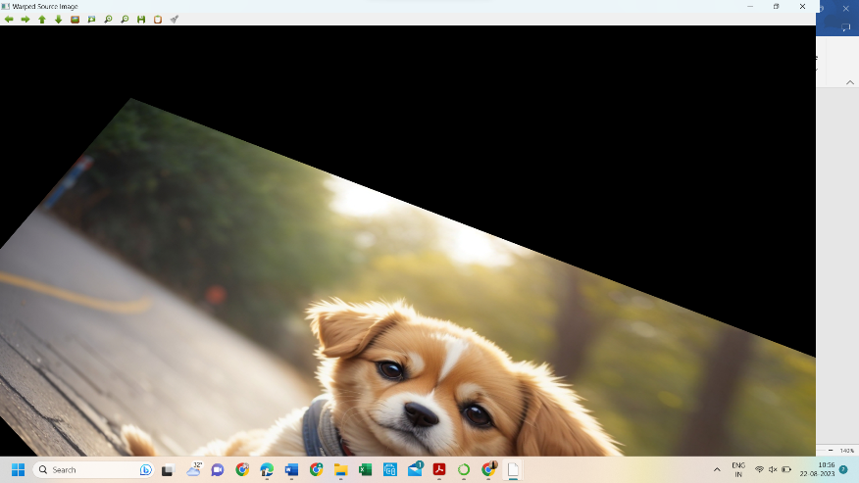

15. Perform transformation using Direct Linear Transformation

PROGRAM:

import cv2

import numpy as np

img1 = cv2.imread("D:\py\cutest-pet-puppy-dog-image.jpg")

img2 = cv2.imread("D:\py\cutest-pet-puppy-dog-image.jpg")

pts1 = np.array([[50, 50], [200, 50], [50, 200], [200, 200]])

pts2 = np.array([[100, 100], [300, 100], [100, 300], [300, 300]])

H, _ = cv2.findHomography(pts1, pts2)

dst = cv2.warpPerspective(img1, H, (img2.shape[1], img2.shape[0]))

cv2.imshow('img1', img1)

cv2.imshow('img2', img2)

cv2.imshow('dst', dst)

cv2.waitKey(0)

cv2.destroyAllWindows()

INPUT:



OUTPUT:

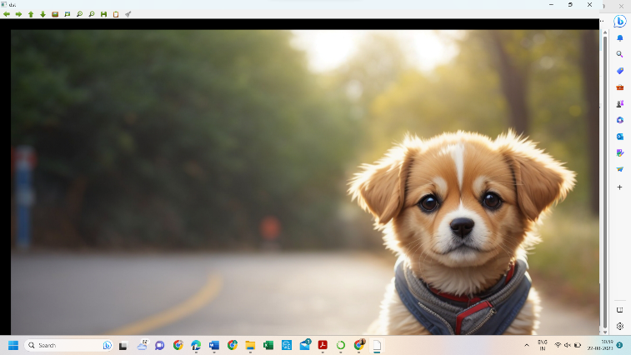

16. Perform Edge detection using canny method

PROGRAM:

import cv2

img = cv2.imread("D:\py\photo-1597655601841-214a4cfe8b2c.jpeg")

img_gray = cv2.cvtColor(img, cv2.COLOR_BGR2GRAY)

img_blur = cv2.GaussianBlur(img_gray, (3,3), 0)

edges = cv2.Canny(image=img_blur, threshold1=100, threshold2=200)

cv2.imshow('Canny Edge Detection', edges)

cv2.waitKey(0)

cv2.destroyAllWindows()

INPUT:

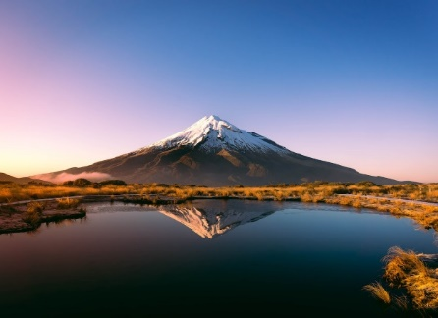

OUTPUT:

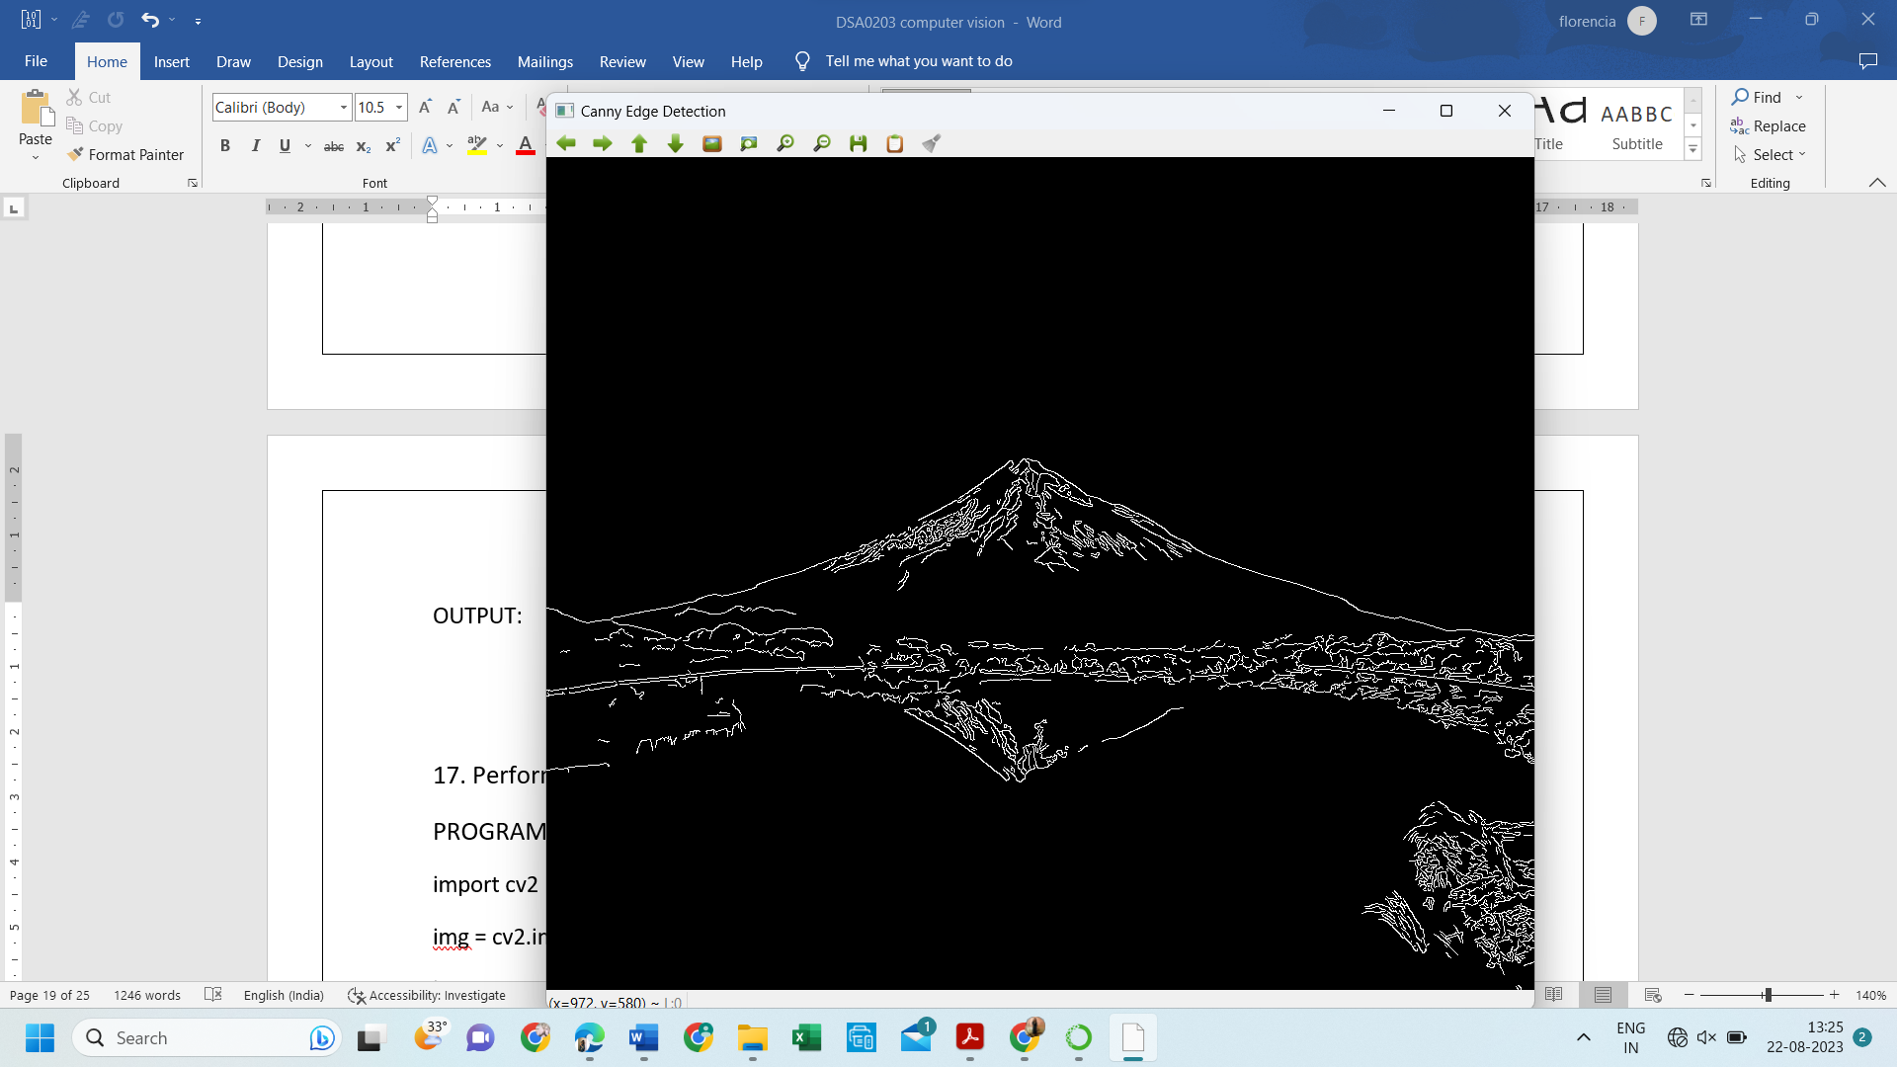

17. Perform Edge detection using Sobel Matrix along X axis

PROGRAM:

import cv2

img = cv2.imread("D:\py\photo-1597655601841-214a4cfe8b2c.jpeg")

img_gray = cv2.cvtColor(img, cv2.COLOR_BGR2GRAY)

img_blur = cv2.GaussianBlur(img_gray, (3,3), 0)

sobelx = cv2.Sobel(src=img_blur, ddepth=cv2.CV_64F, dx=1, dy=0, ksize=5)

cv2.imshow('Sobel X', sobelx)

cv2.waitKey(0)

INPUT:

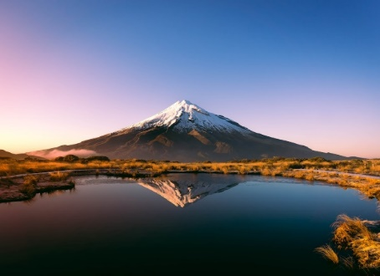

OUTPUT:

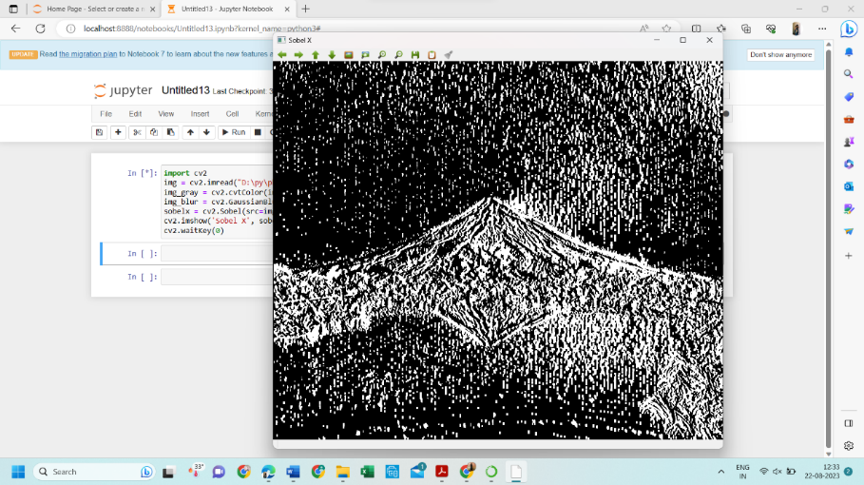

18. Perform Edge detection using Sobel Matrix along Y axis

PROGRAM:

import cv2

img = cv2.imread("D:\py\photo-1597655601841-214a4cfe8b2c.jpeg")

img_gray = cv2.cvtColor(img, cv2.COLOR_BGR2GRAY)

img_blur = cv2.GaussianBlur(img_gray, (3,3), 0)

sobely = cv2.Sobel(src=img_blur, ddepth=cv2.CV_64F, dx=0, dy=1, ksize=5)

cv2.imshow('Sobel Y', sobely)

cv2.waitKey(0)

INPUT:

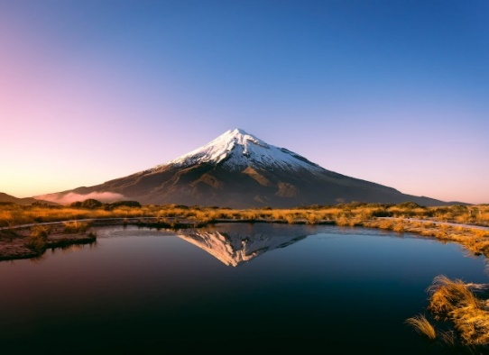

OUTPUT:

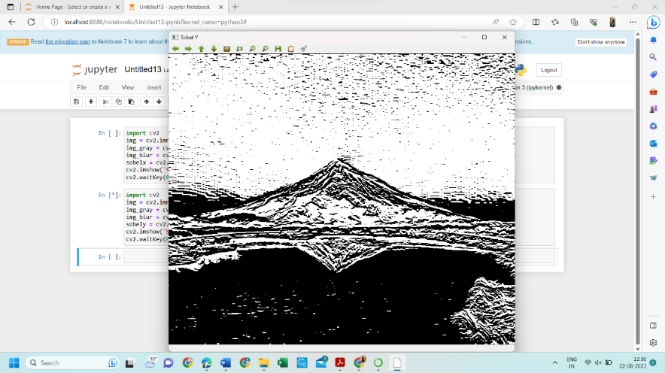

19. Perform Edge detection using Sobel Matrix along XY axis

PROGRAM:

import cv2

img = cv2.imread("D:\py\photo-1597655601841-214a4cfe8b2c.jpeg")

img_gray = cv2.cvtColor(img, cv2.COLOR_BGR2GRAY)

img_blur = cv2.GaussianBlur(img_gray, (3,3), 0)

sobelxy = cv2.Sobel(src=img_blur, ddepth=cv2.CV_64F, dx=1, dy=1, ksize=5)

cv2.imshow('Sobel X Y using Sobel() function', sobelxy)

cv2.waitKey(0)

INPUT:

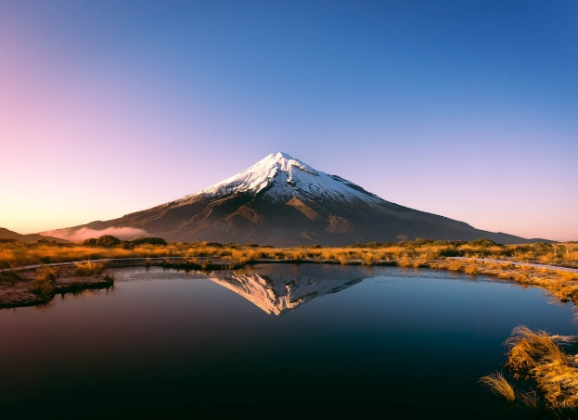

OUTPUT:

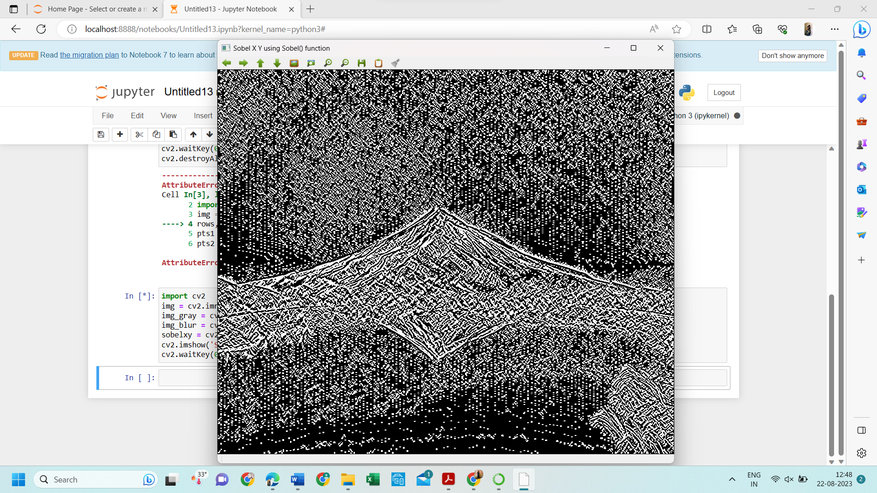

20. Perform Sharpening of Image using Laplacian mask with negative center coefficient

PROGRAM:

import cv2

import numpy as np

img = cv2.imread("D:\py\photo-1597655601841-214a4cfe8b2c.jpeg")

gray = cv2.cvtColor(img, cv2.COLOR_BGR2GRAY)

kernel = np.array([[0,1,0], [1,-8,1], [0,1,0]])

sharpened = cv2.filter2D(gray, -1, kernel)

cv2.imshow('Sharpened', sharpened)

cv2.waitKey(0)

cv2.destroyAllWindows()

INPUT:



OUTPUT:

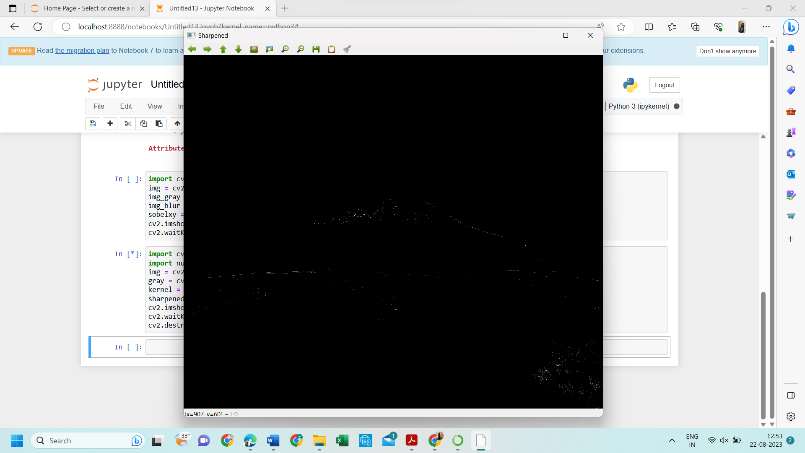

21. Perform Sharpening of Image using Laplacian mask implemented with an extension of

diagonal neighbors,

PROGRAM:

import cv2

import numpy as np

img = cv2.imread("D:\py\photo-1597655601841-214a4cfe8b2c.jpeg")

gray = cv2.cvtColor(img, cv2.COLOR_BGR2GRAY)

kernel = np.array([[0,1,0], [1,-4,1], [0,1,0]])

sharpened = cv2.filter2D(gray, -1, kernel)

cv2.imshow('Original', gray)

cv2.imshow('Sharpened', sharpened)

cv2.waitKey(0)

cv2.destroyAllWindows()

INPUT:

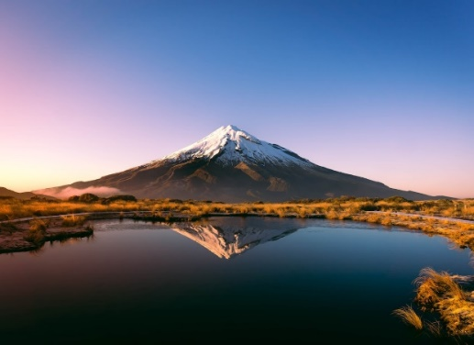

OUTPUT:

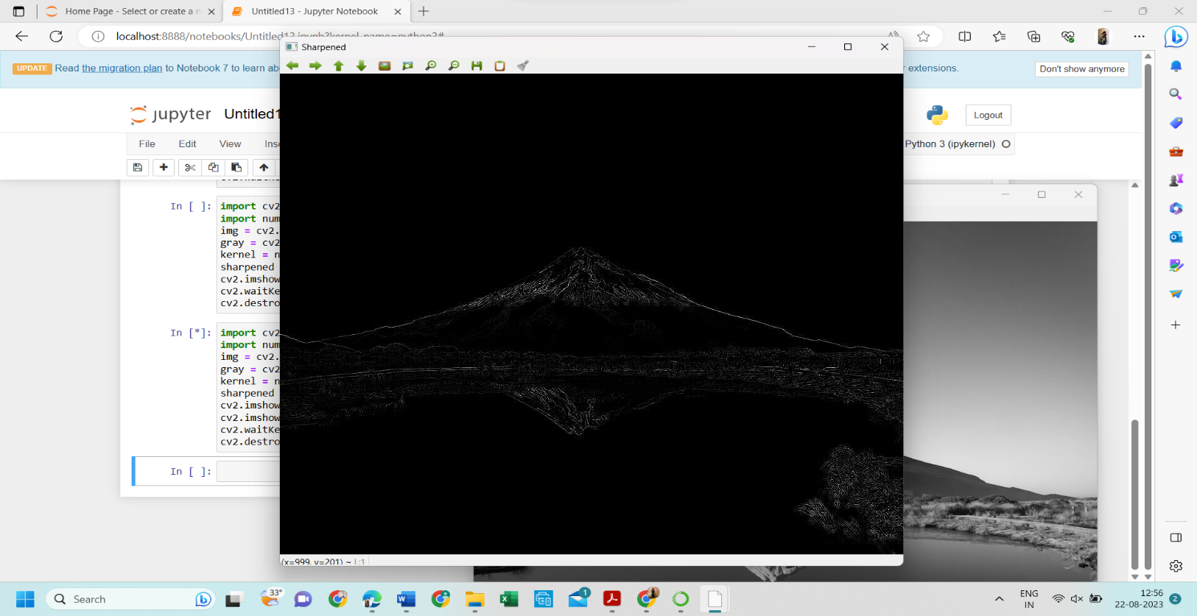

22. Perform Sharpening of Image using Laplacian mask with positive center coefficient.

PROGRAM:

import cv2

import numpy as np

img = cv2.imread("D:\py\photo-1597655601841-214a4cfe8b2c.jpeg")

img = cv2.resize(img,(255, 255))

gray_img = cv2.cvtColor(img, cv2.COLOR_BGR2GRAY)

laplacian_kernel = np.array([[0, -1, 0], [-1, 5, -1], [0, -1, 0]])

sharpened_img = cv2.filter2D(gray_img, -1, laplacian_kernel)

sharpened_img = cv2.cvtColor(sharpened_img, cv2.COLOR_GRAY2BGR)

cv2.imshow('Original Image', img)

cv2.imshow('Sharpened Image', sharpened_img)

cv2.waitKey(0)

cv2.destroyAllWindows()

INPUT:



OUTPUT:

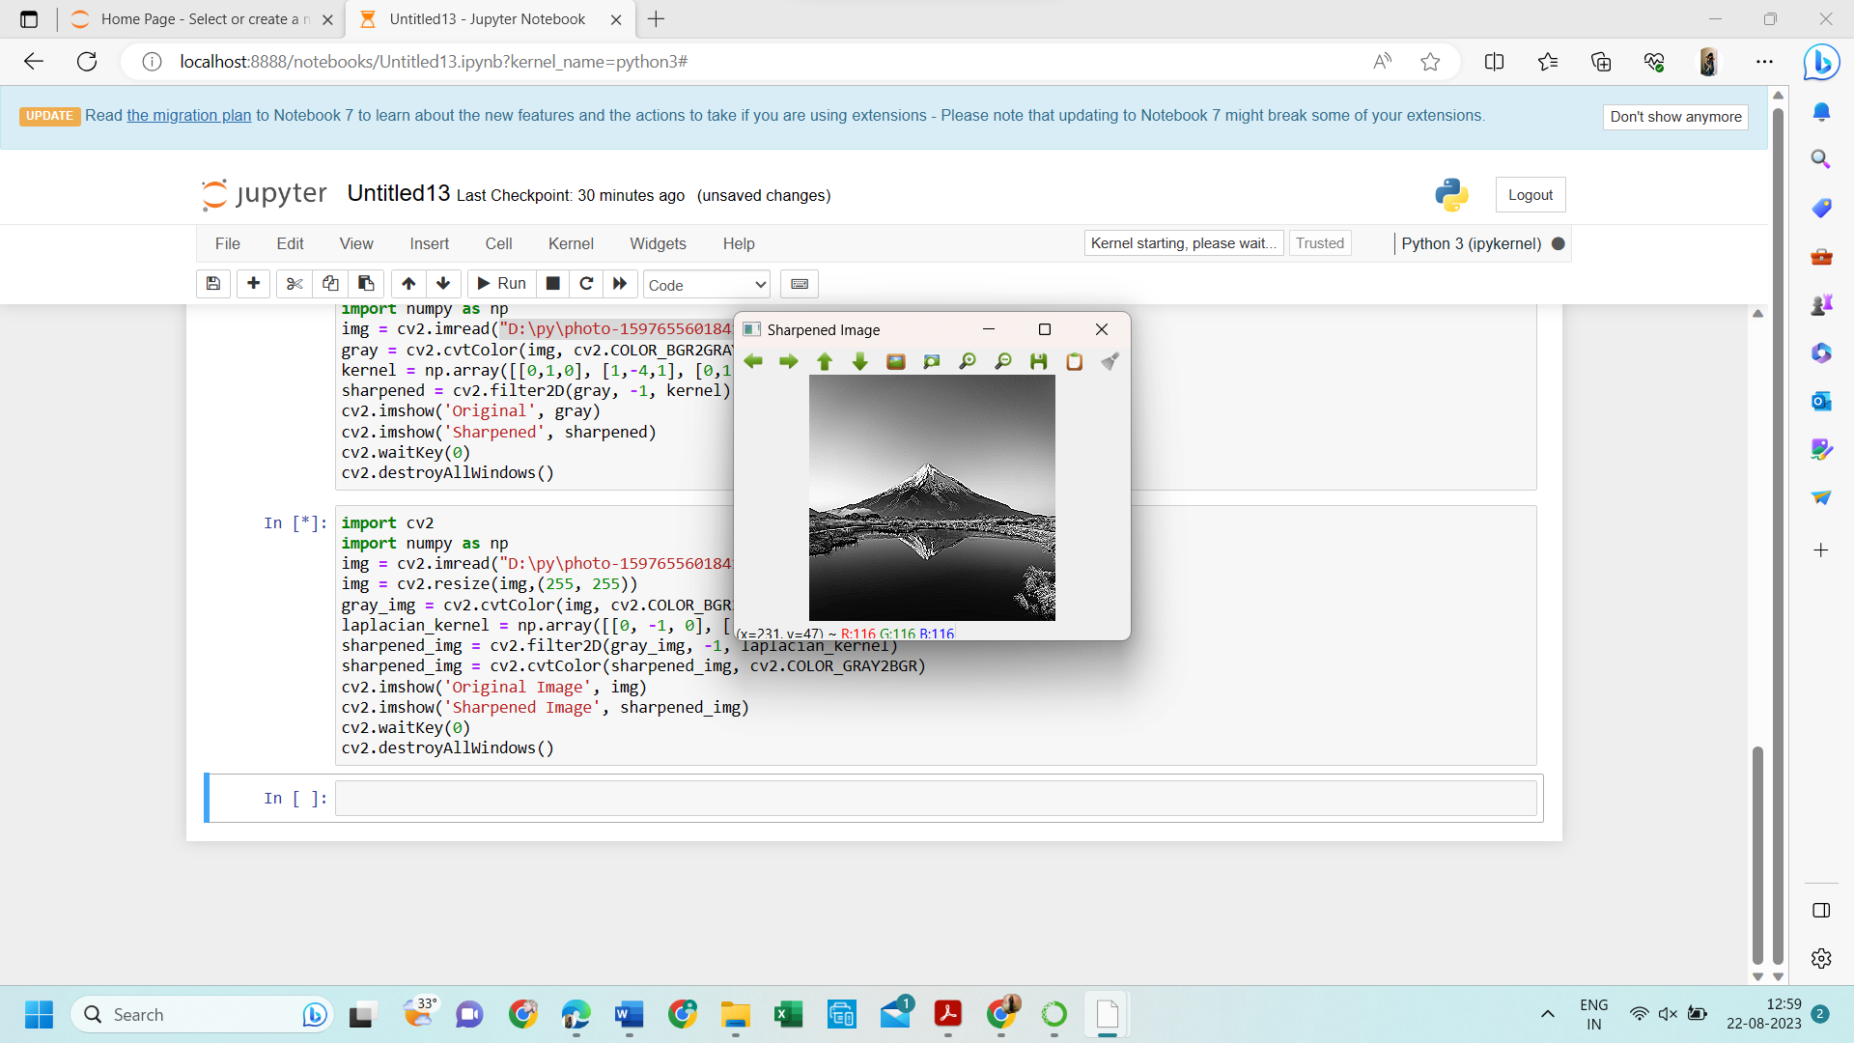

23. Perform Sharpening of Image using unsharp masking.

PROGRAM:

import cv2

import numpy as np

img = cv2.imread("D:\py\photo-1597655601841-214a4cfe8b2c.jpeg")

gray = cv2.cvtColor(img, cv2.COLOR_BGR2GRAY)

laplacian_kernel = np.array([[0, 1, 0],

[1, -4, 1],

[0, 1, 0]])

laplacian = cv2.filter2D(gray, -1, laplacian_kernel)

sharpened = cv2.add(gray, laplacian)

cv2.imshow('Original Image', gray)

cv2.imshow('Sharpened Image', sharpened)

cv2.waitKey(0)

cv2.destroyAllWindows()

INPUT:



OUTPUT:

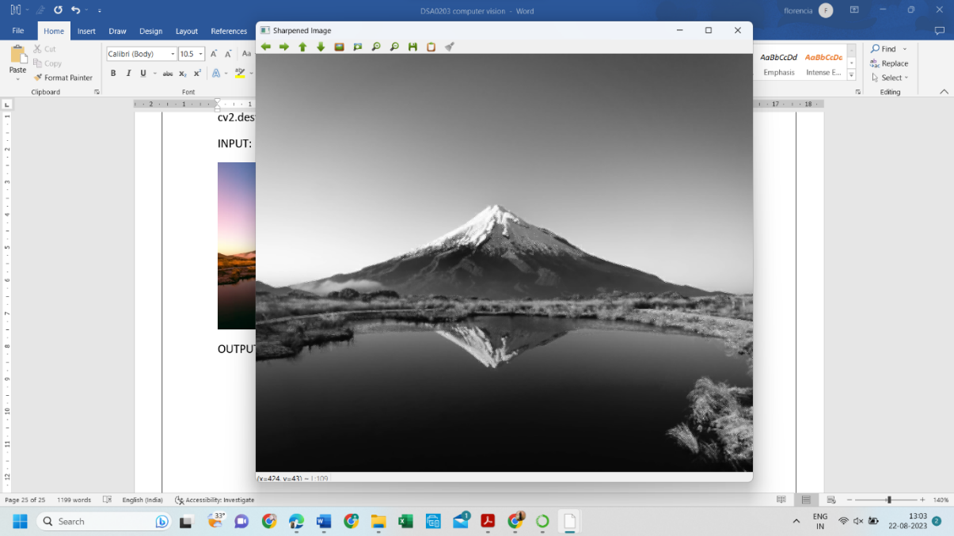

24. Perform Sharpening of Image using High-Boost Masks.

PROGRAM:

import cv2

import numpy as np

import matplotlib.pyplot as plt

def high_boost_sharpening(image_path, k=1.5):

original_image = cv2.imread(image_path, cv2.IMREAD_GRAYSCALE)

blurred_image = cv2.GaussianBlur(original_image, (5, 5), 0)

high_pass = original_image - blurred_image

sharpened_image = original_image + k * high_pass

return original_image, sharpened_image

image_path = "D:\py\cutest-pet-puppy-dog-image.jpg"

original_image, sharpened_image = high_boost_sharpening(image_path, k=1.5)

plt.figure(figsize=(10, 5))

plt.subplot(1, 3, 1)

plt.subplot(1, 3, 2)

plt.imshow(sharpened_image, cmap='gray')

plt.title('Sharpened Image')

plt.subplot(1, 3, 3)

plt.imshow(original_image - sharpened_image, cmap='gray')

plt.title('Detail (High-Pass)')

plt.tight_layout()

plt.show()

INPUT:



OUTPUT:

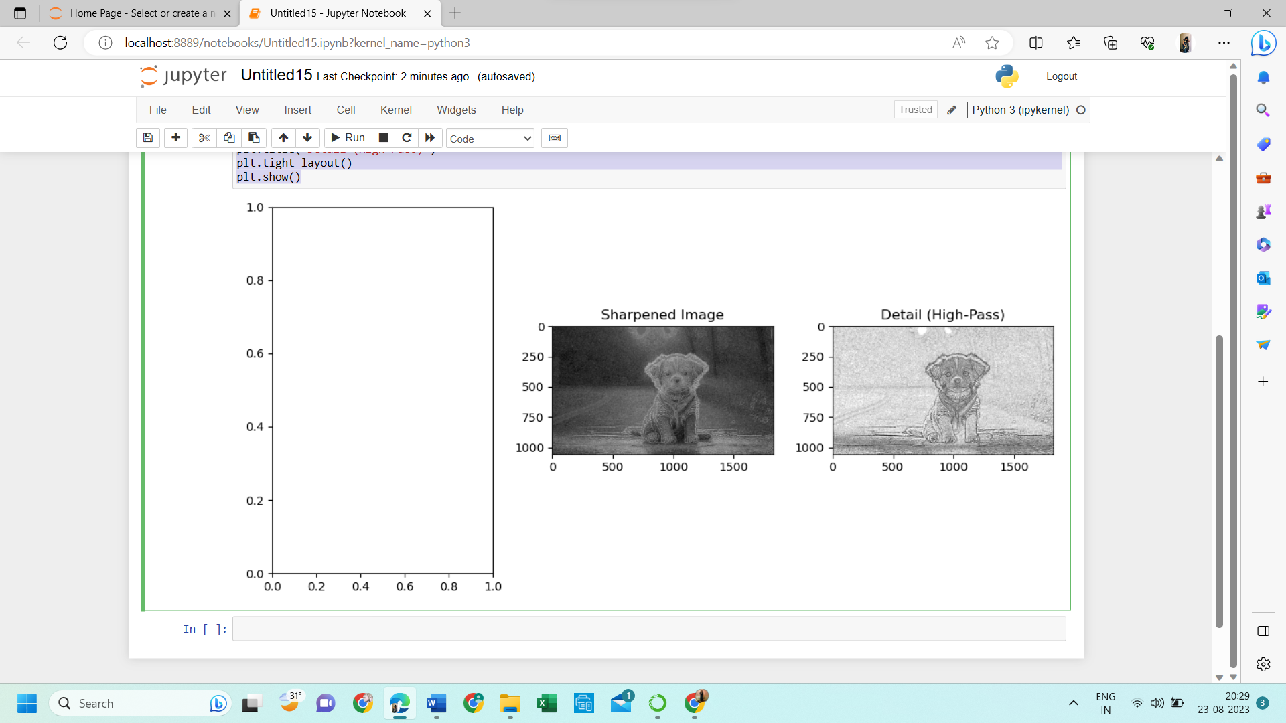

25. Perform Sharpening of Image using Gradient masking

PROGRAM:

import cv2

import numpy as np

import matplotlib.pyplot as plt

def sharpen_image_with_gradient(image_path, alpha=1.5):

original_image = cv2.imread(image_path, cv2.IMREAD_GRAYSCALE)

gradient_x = cv2.Sobel(original_image, cv2.CV_64F, 1, 0, ksize=3)

gradient_y = cv2.Sobel(original_image, cv2.CV_64F, 0, 1, ksize=3)

gradient_magnitude = np.sqrt(gradient_x**2 + gradient_y**2)

gradient_magnitude = cv2.normalize(gradient_magnitude, None, 0, 255, cv2.NORM_MINMAX, cv2.CV_8U)

sharpened_image = cv2.addWeighted(original_image, 1 + alpha, gradient_magnitude, -alpha, 0)

return original_image, sharpened_image

image_path = "D:\py\cutest-pet-puppy-dog-image.jpg"

original_image, sharpened_image = sharpen_image_with_gradient(image_path, alpha=1.5)

plt.figure(figsize=(10, 5))

plt.subplot(1, 2, 1)

plt.imshow(original_image, cmap='gray')

plt.title('Original Image')

plt.subplot(1, 2, 2)

plt.imshow(sharpened_image, cmap='gray')

plt.title('Sharpened Image')

plt.tight_layout()

plt.show()

OUTPUT:

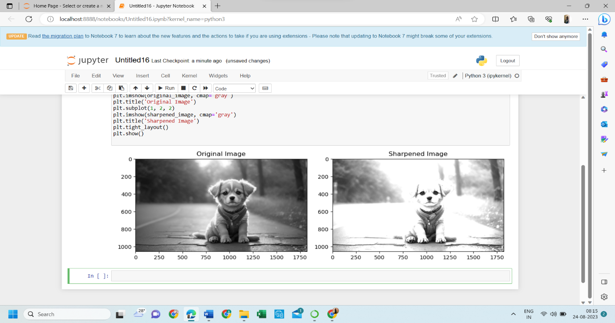

26. Insert water marking to the image using OpenCV.

PROGRAM:

import cv2

img = cv2.imread("D:\py\cutest-pet-puppy-dog-image.jpg")

wm = cv2.imread("D:\py\cutest-pet-puppy-dog-image.jpg")

h_wm, w_wm = wm.shape[:2]

h_img, w_img = img.shape[:2]

center_x = int(w_img/2)

center_y = int(h_img/2)

top_y = center_y - int(h_wm/2)

left_x = center_x - int(w_wm/2)

bottom_y = top_y + h_wm

right_x = left_x + w_wm

roi = img[top_y:bottom_y, left_x:right_x]

result = cv2.addWeighted(roi, 1, wm, 0.3, 0)

img[top_y:bottom_y, left_x:right_x] = result

cv2.imshow("Watermarked Image", img)

cv2.waitKey(0)

cv2.destroyAllWindows()

INPUT:



OUTPUT:

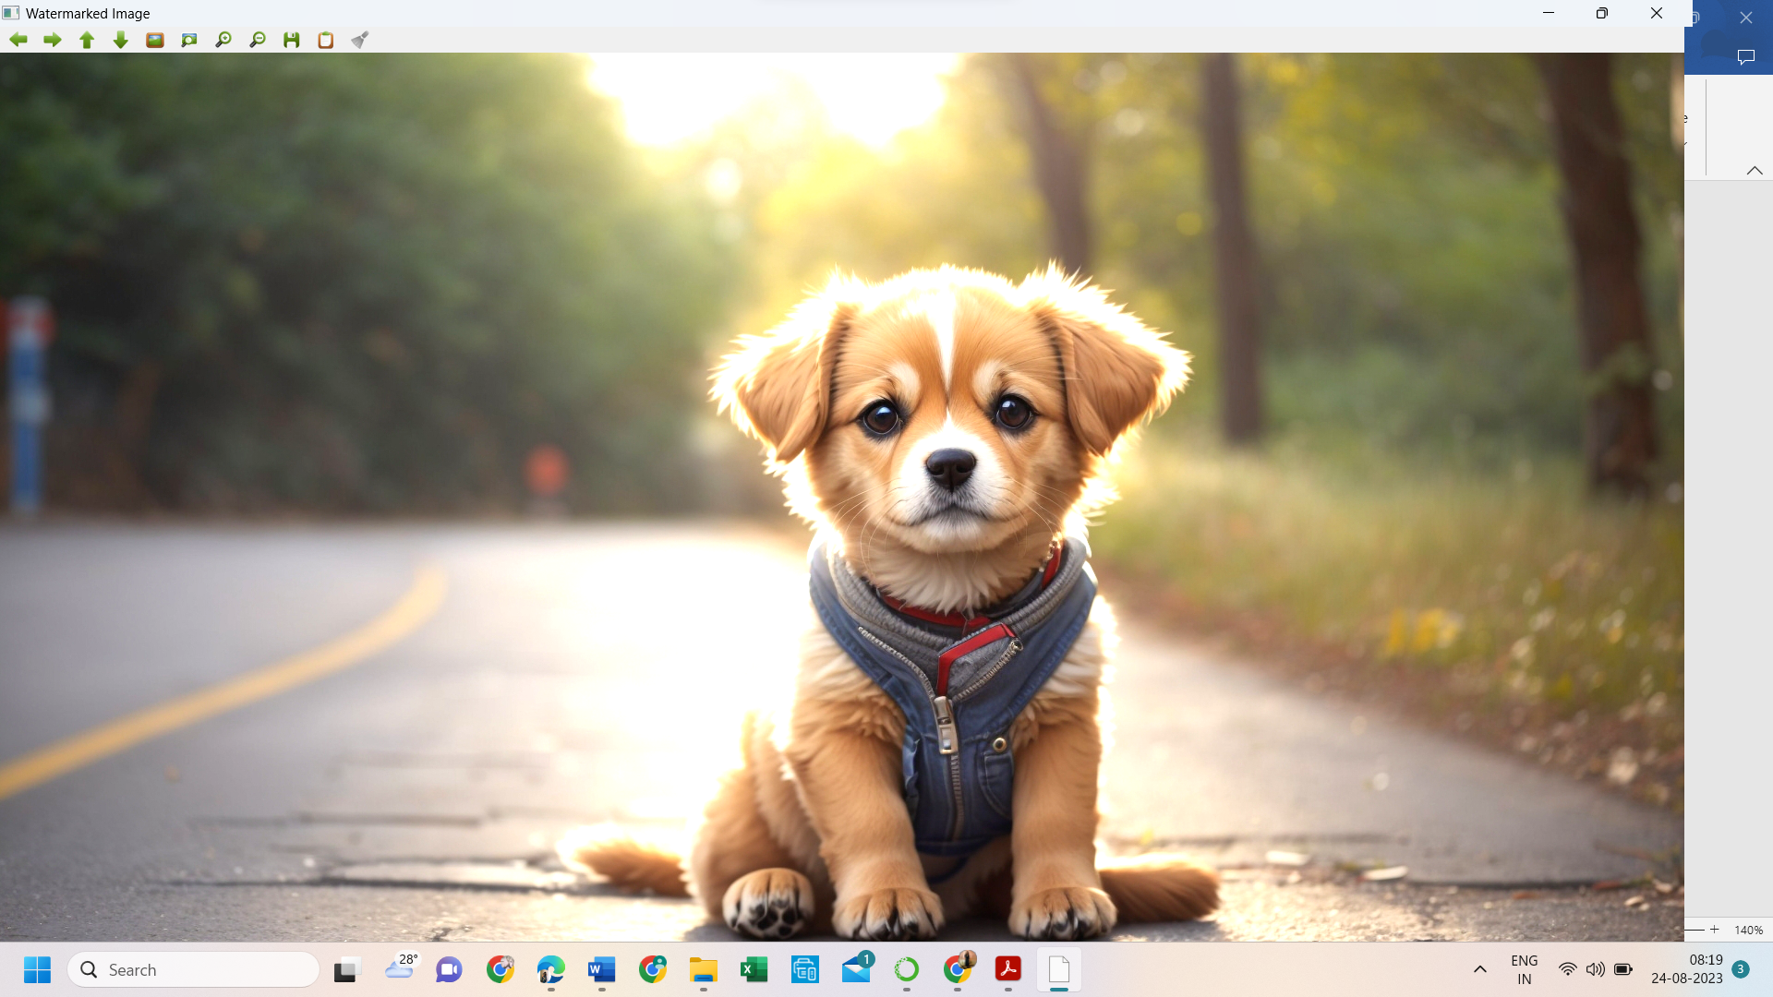

27. Do Cropping, Copying and pasting image inside another image using OpenCV

PROGRAM:

import cv2

import numpy as np

image = cv2.imread("D:\py\photo-1597655601841-214a4cfe8b2c.jpeg")

img2 = cv2.imread("D:\py\photo-1597655601841-214a4cfe8b2c.jpeg")

print(image.shape)

cv2.imshow("original", image)

imageCopy = image.copy()

cv2.circle(imageCopy, (100, 100), 30, (255, 0, 0), -1)

cv2.imshow('image', image)

cv2.imshow('image copy', imageCopy)

cropped_image = image[80:280, 150:330]

cv2.imshow("cropped", cropped_image)

cv2.imwrite("Cropped Image.jpg", cropped_image)

dst = cv2.addWeighted(image, 0.5, img2, 0.7, 0)

img_arr = np.hstack((image, img2))

cv2.imshow('Input Images',img_arr)

cv2.imshow('Blended Image',dst)

cv2.waitKey(0)

cv2.destroyAllWindows()

OUTPUT:

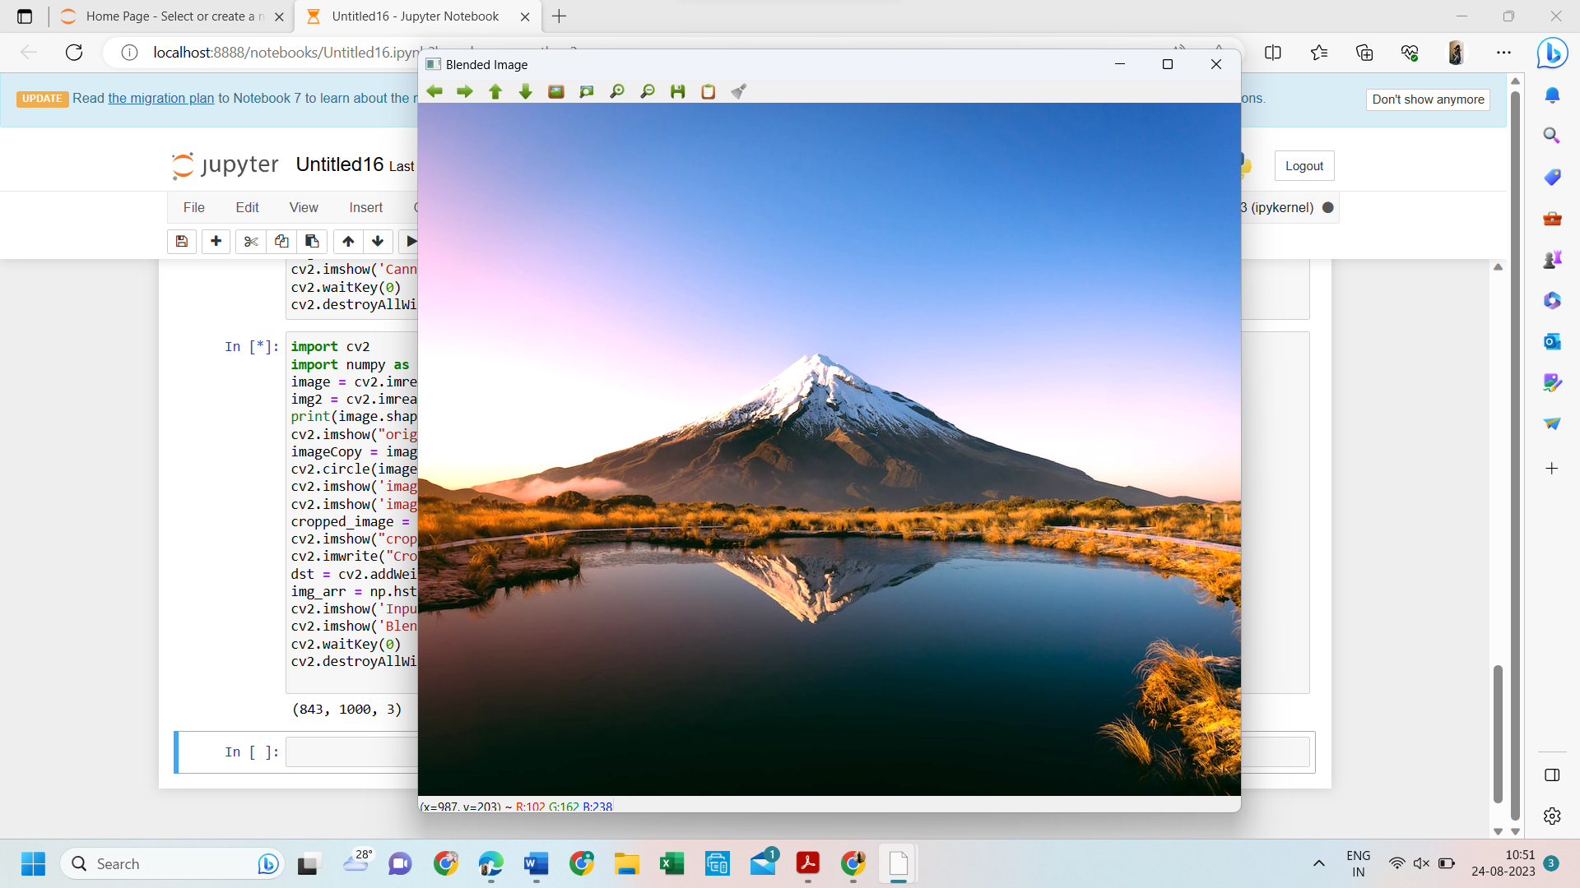

28. Find the boundary of the image using Convolution kernel for the given image

PROGRAM:

import cv2

import numpy as np

img = cv2.imread("D:\py\photo-1597655601841-214a4cfe8b2c.jpeg",cv2.IMREAD_GRAYSCALE)

dx = cv2.Sobel(img, cv2.CV_64F, 1, 0)

dy = cv2.Sobel(img, cv2.CV_64F, 0, 1)

edges = cv2.magnitude(dx, dy)

thresh = 100

edges[edges < thresh] = 0

edges[edges >= thresh] = 255

cv2.imshow("Edges", edges)

cv2.waitKey(0)

cv2.destroyAllWindows()

OUTPUT:

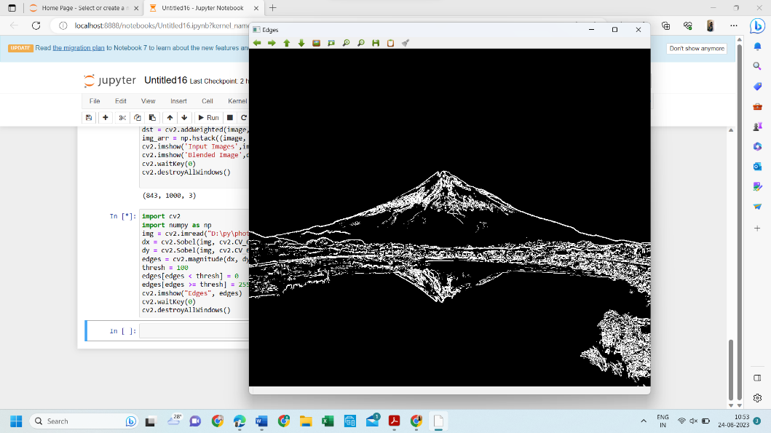

29. Morphological operations based on OpenCV using Erosion technique

PROGRAM:

import cv2

import numpy as np

img = cv2.imread("D:\py\photo-1597655601841-214a4cfe8b2c.jpeg",cv2.IMREAD_GRAYSCALE)

kernel = np.ones((5,5), np.uint8)

erosion = cv2.erode(img, kernel, iterations=1)

cv2.imshow("Original", img)

cv2.imshow("Erosion", erosion)

cv2.waitKey(0)

cv2.destroyAllWindows()

OUTPUT:

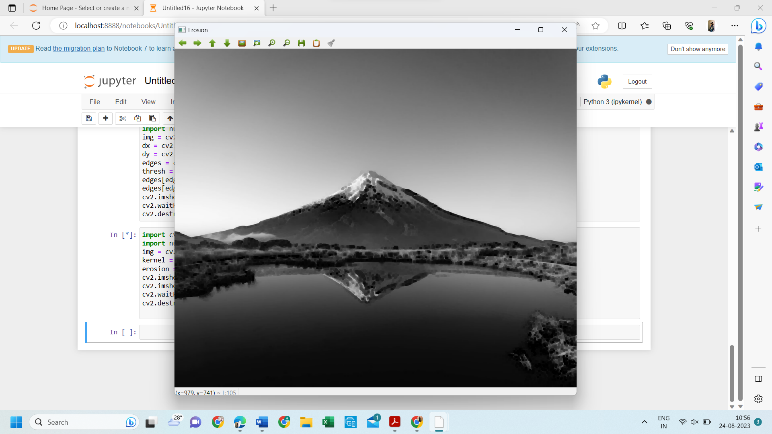

30. Morphological operations based on OpenCV using Dilation technique

PROGRAM:

import cv2

import numpy as np

img = cv2.imread("D:\py\cutest-pet-puppy-dog-image.jpg", cv2.IMREAD_GRAYSCALE)

kernel = np.ones((5,5), np.uint8)

dilation = cv2.dilate(img, kernel, iterations=1)

cv2.imshow("Original", img)

cv2.imshow("Dilation", dilation)

cv2.waitKey(0)

cv2.destroyAllWindows()

INPUT:



OUTPUT:

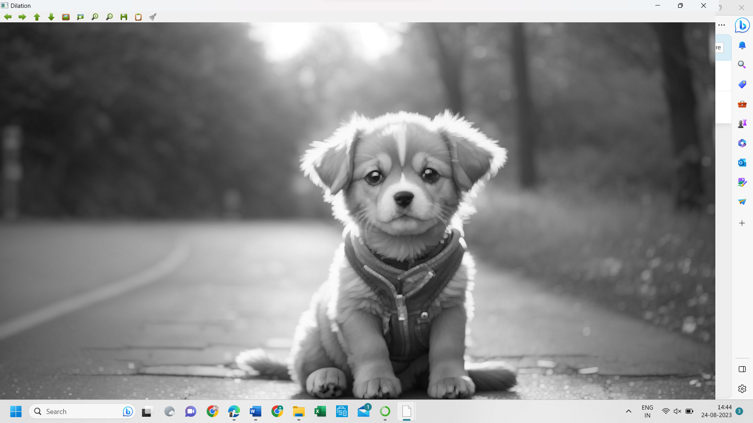

31. Morphological operations based on OpenCV using Opening technique.

PROGRAM:

import cv2

import numpy as np

img = cv2.imread("D:\py\cutest-pet-puppy-dog-image.jpg", cv2.IMREAD_GRAYSCALE)

kernel = np.ones((5,5), np.uint8)

opening = cv2.morphologyEx(img, cv2.MORPH_OPEN, kernel)

cv2.imshow("Original", img)

cv2.imshow("opening", opening)

cv2.waitKey(0)

cv2.destroyAllWindows()

INPUT:



OUTPUT:

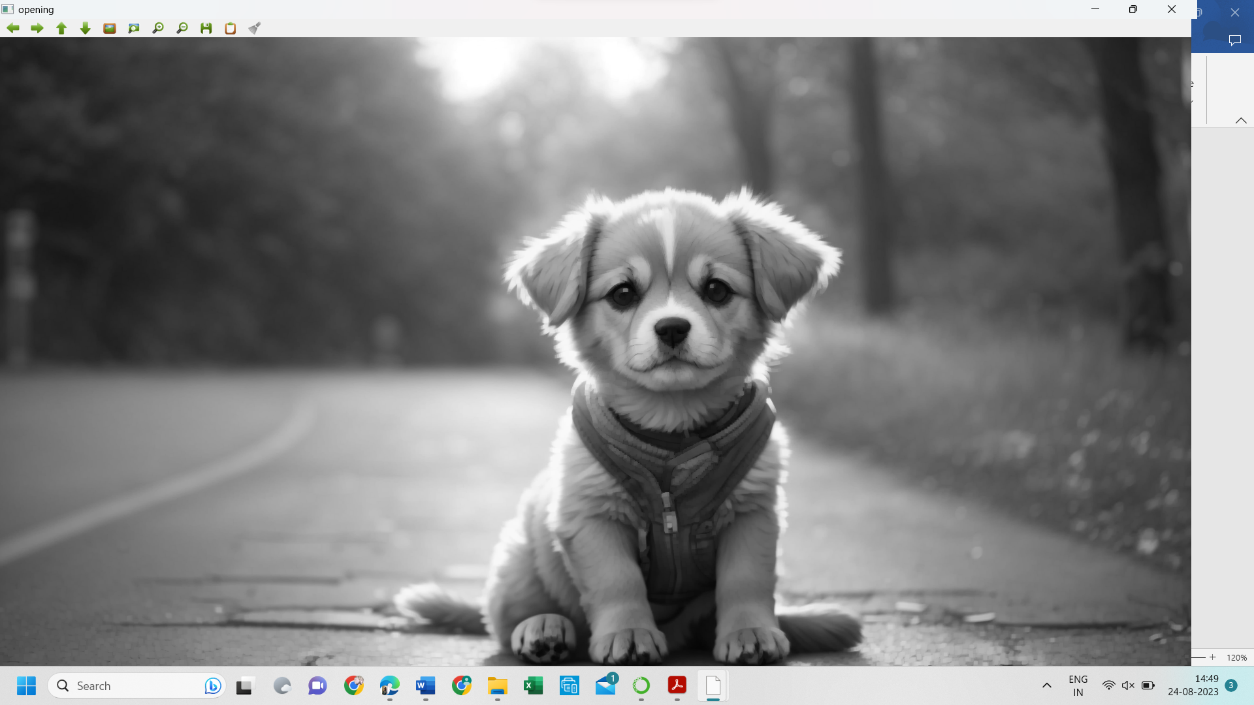

32. Morphological operations based on OpenCV using Closing technique.

PROGRAM:

import cv2

import numpy as np

img = cv2.imread("D:\py\cutest-pet-puppy-dog-image.jpg", cv2.IMREAD_GRAYSCALE)

kernel = np.ones((5,5), np.uint8)

closing = cv2.morphologyEx(img, cv2.MORPH_CLOSE, kernel)

cv2.imshow("Original", img)

cv2.imshow("Closing", closing)

cv2.waitKey(0)

cv2.destroyAllWindows()

INPUT:



OUTPUT:

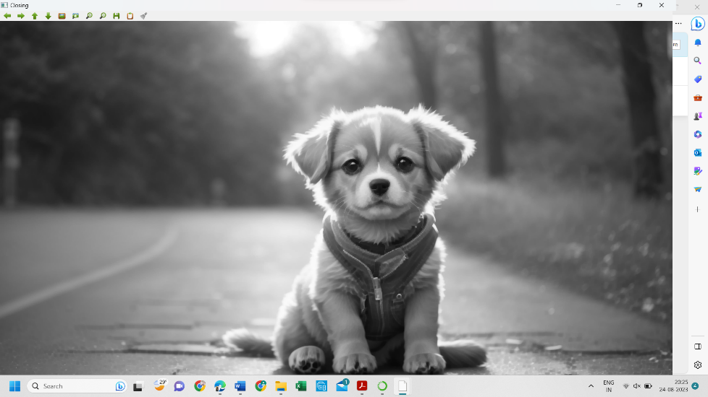

33. Morphological operations based on OpenCV using Morphological Gradient technique

PROGRAM:

import cv2

import numpy as np

img = cv2.imread("D:\py\cutest-pet-puppy-dog-image.jpg", cv2.IMREAD_GRAYSCALE)

kernel = np.ones((5,5), np.uint8)

grad = cv2.morphologyEx(img, cv2.MORPH_GRADIENT, kernel)

cv2.imshow("Original", img)

cv2.imshow("Gradient", grad)

cv2.waitKey

34. Morphological operations based on OpenCV using Top hat technique

PROGRAM:

import cv2

import numpy as np

img = cv2.imread("D:\py\cutest-pet-puppy-dog-image.jpg", cv2.IMREAD_GRAYSCALE)

kernel = np.ones((5,5), np.uint8)

tophat = cv2.morphologyEx(img, cv2.MORPH_TOPHAT, kernel)

cv2.imshow("Original", img)

cv2.imshow("Top Hat", tophat)

cv2.waitKey(0)

cv2.destroyAllWindows()

INPUT:



OUTPUT:

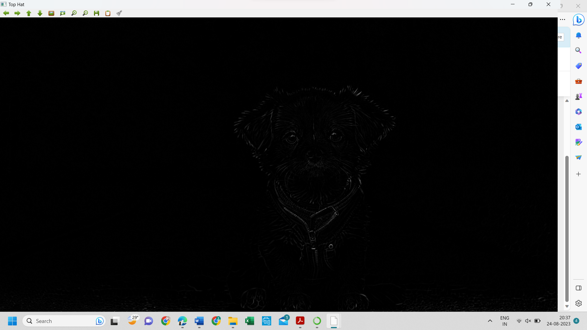

35. Morphological operations based on OpenCV using Black hat technique

PROGRAM:

import cv2

import numpy as np

img = cv2.imread("D:\py\cutest-pet-puppy-dog-image.jpg", cv2.IMREAD_GRAYSCALE)

kernel = np.ones((5,5), np.uint8)

blackhat = cv2.morphologyEx(img, cv2.MORPH_BLACKHAT, kernel)

cv2.imshow("Original", img)

cv2.imshow("Black Hat", blackhat)

cv2.waitKey(0)

cv2.destroyAllWindows()

INPUT:



OUTPUT:

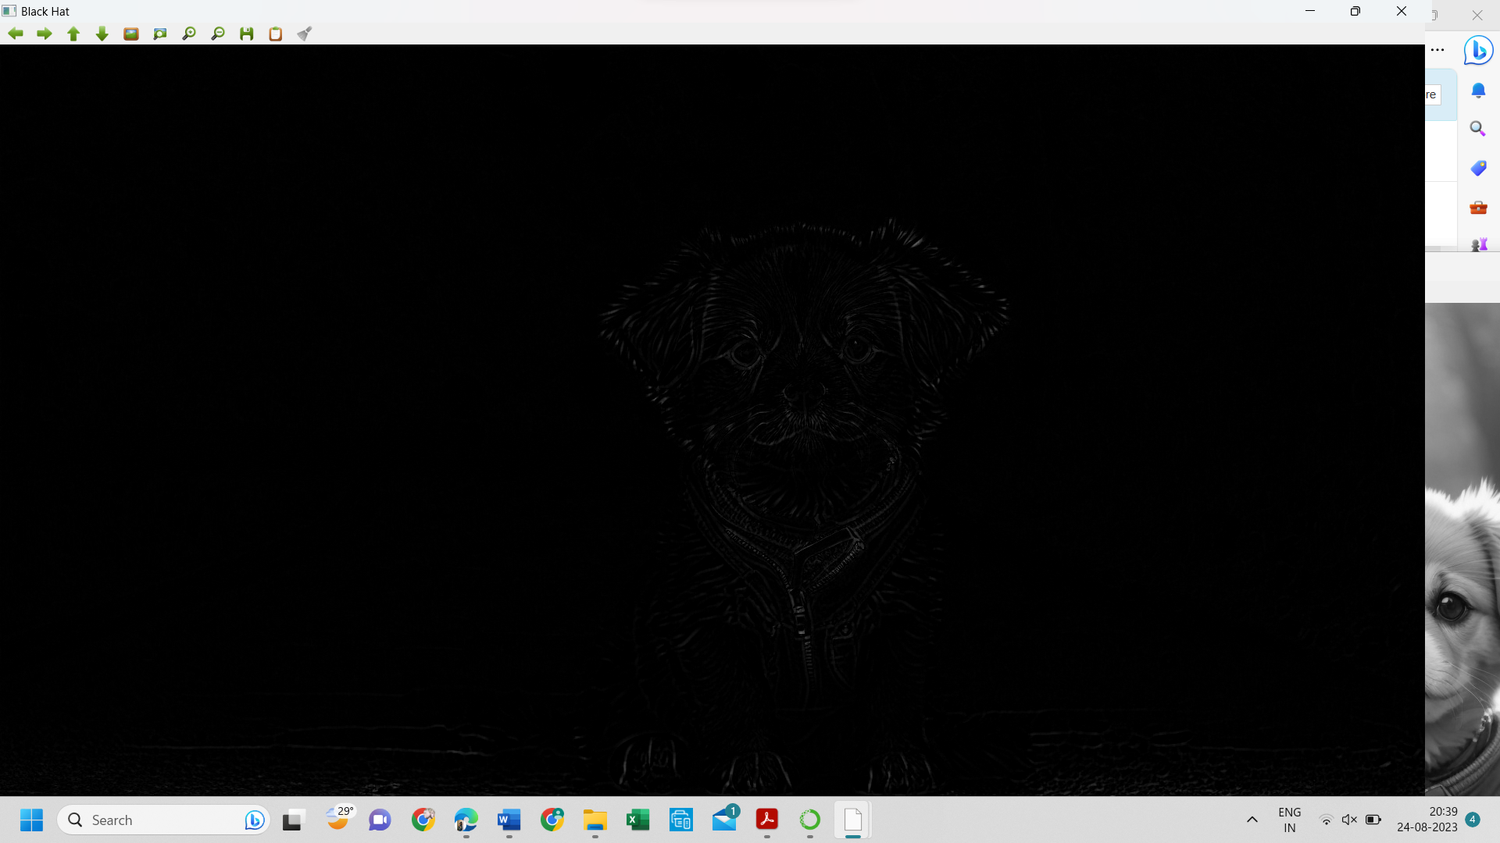

36. Recognise watch from the given image by general Object recognition using OpenCV

PROGRAM:

import cv2

watch_cascade = cv2.CascadeClassifier("D:\py\watch-cascade.xml")

img = cv2.imread("D:\py\cutest-pet-puppy-dog-image.jpg")

gray = cv2.cvtColor(img, cv2.COLOR_BGR2GRAY)

watches = watch_cascade.detectMultiScale(gray, scaleFactor=1.2, minNeighbors=5)

for (x, y, w, h) in watches:

cv2.rectangle(img, (x, y), (x + w, y + h), (0, 255, 0), 2)

cv2.imshow('Watches Detected', img)

cv2.waitKey(0)

cv2.destroyAllWindows()

INPUT:



OUTPUT:

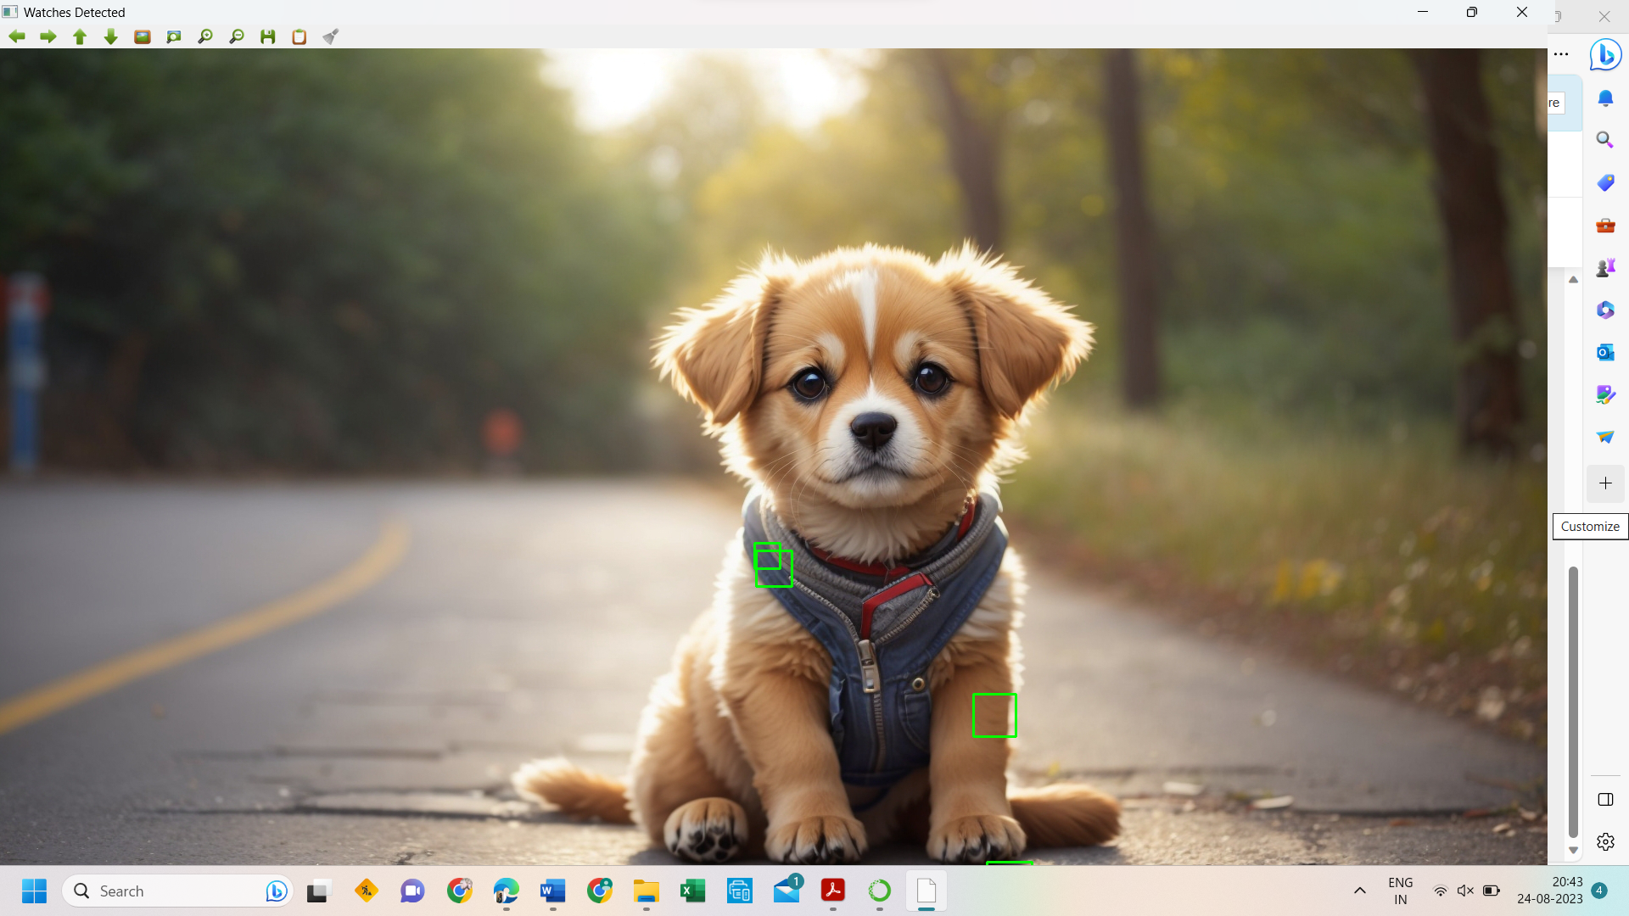

37. Using Opencv play Video in Reverse mode.

PROGRAM:

import cv2

cap = cv2.VideoCapture("D:\py\The Summer I Turned Pretty ( S1E1-meeting scene).mp4")

total_frames = cap.get(cv2.CAP_PROP_FRAME_COUNT)

current_frame = total_frames - 1

while current_frame >= 0:

cap.set(cv2.CAP_PROP_POS_FRAMES, current_frame)

ret, frame = cap.read()

if not ret:

break

cv2.imshow('Video in Reverse', frame)

if cv2.waitKey(25) & 0xFF == ord('q'):

break

current_frame -= 1

cap.release()

cv2.destroyAllWindows()

38. Face Detection using Opencv

PROGRAM:

import cv2

img = cv2.imread("D:\py\cutest-pet-puppy-dog-image.jpg")

gray = cv2.cvtColor(img, cv2.COLOR_BGR2GRAY)

face_cascade = cv2.CascadeClassifier("D:\py\watch-cascade.xml")

faces = face_cascade.detectMultiScale(gray, scaleFactor=1.1, minNeighbors=5)

for (x, y, w, h) in faces:

cv2.rectangle(img, (x, y), (x + w, y + h), (0, 255, 0), 2)

cv2.imshow('Faces Detected', img)

cv2.waitKey(0)

cv2.destroyAllWindows()

INPUT:



OUTPUT:

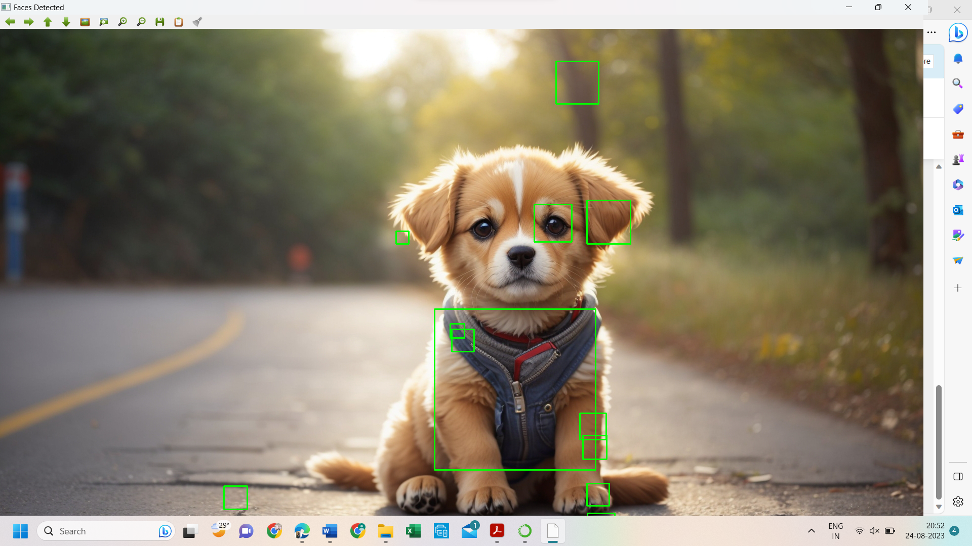

39. Vehicle Detection in a Video frame using OpenCV

PROGRAM:

import cv2

car_cascade = cv2.CascadeClassifier("D:\py\watch-cascade.xml")

cap = cv2.VideoCapture("D:\py\The Summer I Turned Pretty ( S1E1-meeting scene).mp4")

while True:

ret, frame = cap.read()

gray = cv2.cvtColor(frame, cv2.COLOR_BGR2GRAY)

cars = car_cascade.detectMultiScale(gray, 1.1, 1)

for (x,y,w,h) in cars:

cv2.rectangle(frame, (x,y), (x+w,y+h), (0,0,255), 2)

cv2.imshow('frame', frame)

if cv2.waitKey(1) & 0xFF == ord('q'):

break

cap.release()

cv2.destroyAllWindows()

OUTPUT:

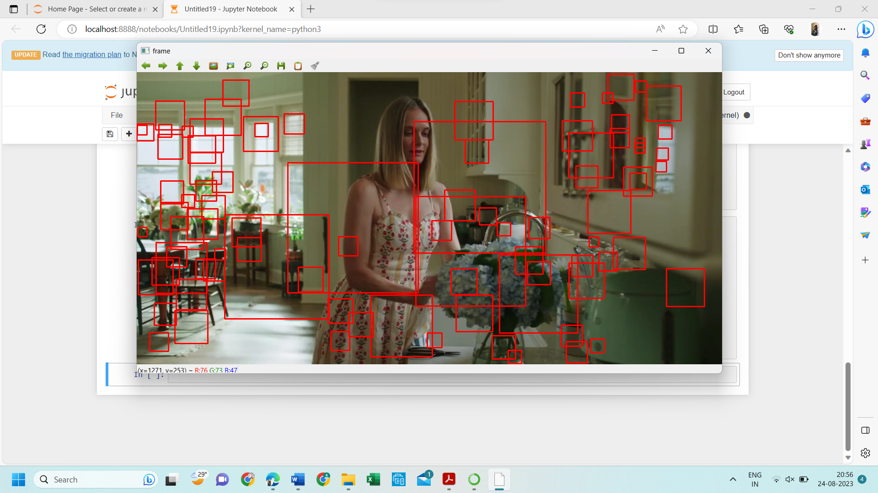

40. Draw Rectangular shape and extract objects

PROGRAM:

import cv2

img = cv2.imread("D:\py\cutest-pet-puppy-dog-image.jpg")

x, y = 100, 100

width, height = 200, 150

roi = img[y:y+height, x:x+width]

cv2.imshow('ROI', roi)

cv2.waitKey(0)

cv2.destroyAllWindows()

INPUT:



OUTPUT:

